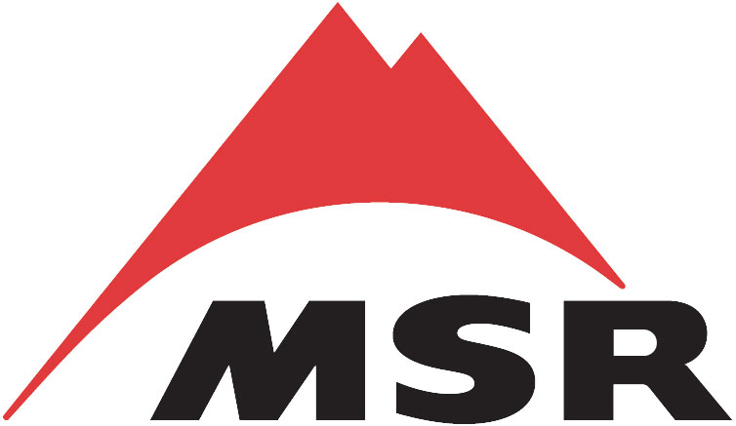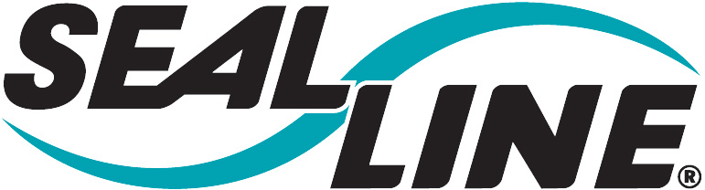

Friends of the Industry Pro Deal and Outfitter Sales Program
PLEASE READ THIS BEFORE CALLING

Forms
We’ve attached the necessary forms you’ll need for placing your order. You will need Microsoft Office Excel to view the forms. The order form is on a second tab of the pricelist.

Ordering
You can place your order by fax. Please fill out the form completely and legibly (if you are unable to print clearly, and you know who you are; have a pal do it). If you are placing a large group order, please consolidate orders onto one form. This will expedite the order process. If you are approved as an individual program member, this product is meant for you alone (not your friends, family or roommate’s uncle once removed). Please allow 2-4 weeks for your order. We accept Visa, MasterCard and American Express cards. Also note, no rush orders!

Shipping
Expedited shipping is not available on Friends of the Industry orders. When you receive your order, you will not receive an itemized receipt. If it is important that you receive one, please contact me by email after you’ve received your order.

Returns
Please make sure that you’ve listed the correct part number and quantity on the form because there are no returns. If we find out that you are exchanging FOI purchased product through our retailers, we will terminate your account.

Discretion
The Friends of the Industry Program is intended to help outdoor professionals get the gear they need at a discounted price. It is important that you maintain a harmonious relationship with our retailers. Please do not take up their time if you are not going to purchase the product from them. You should never mention the Friends program in front of any store’s customers. If people ask you about Cascade Designs equipment refer them to your local retailer.

Order Verification
If you need confirmation that we’ve received your order, email me the organization’s name (first line of the order form), the first name and the last name of the person ordering.

Checking out Product
If you need to check out our products, please refer to the website at www.cascadedesigns.com.

Friends of the Industry, Cascade Designs, 4225 2nd Ave S, Seattle, WA. 98134 ● phone:800 527-1527 x 1414 fax:800 583-7583 friends@cascadedesigns.com

